**Project Design Phase- 3**

**Data Flow Diagram & User Stories**

|  |  |
| --- | --- |
| Date | 23rd October 2023 |
| Team ID | Team - 592719 |
| Project Name | Project - Jungle Detectives: AI-Powered Image Classification of Wild Big Cats |
| Maximum Marks | 4 Marks |

**Data Flow Diagrams:**

A Data Flow Diagram (DFD) is a traditional visual representation of the information flows within a system. A neat and clear DFD can depict the right amount of the system requirement graphically. It shows how data enters and leaves the system, what changes the information, and where data is stored.

**Diagrams:**

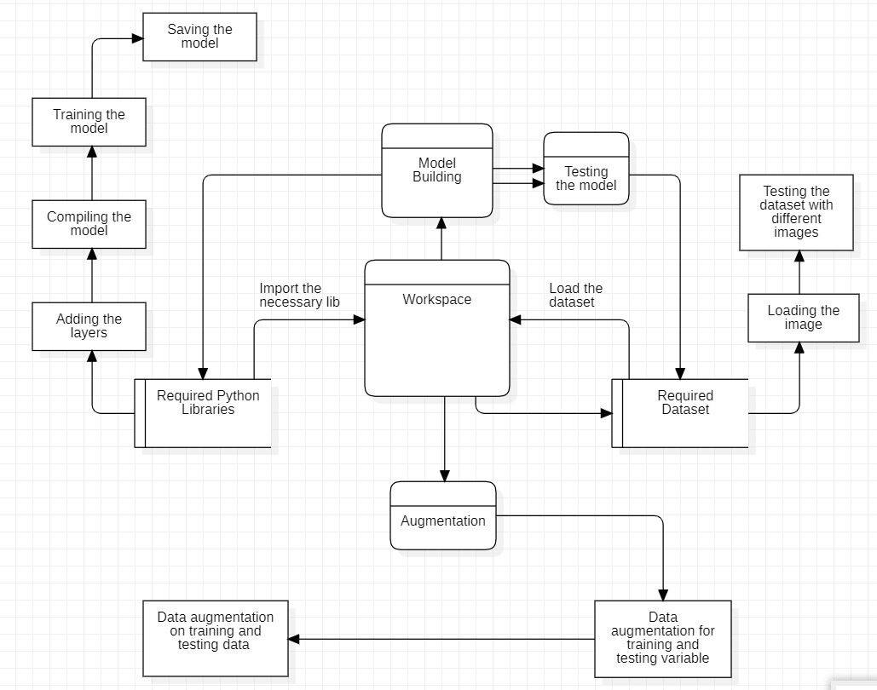

**User Stories**

Use the below template to list all the user stories for the product.

|  |  |  |  |  |  |  |
| --- | --- | --- | --- | --- | --- | --- |
| **User Type** | **Functional**  **Requirement (Epic)** | **User Story**  **Number** | **User Story / Task** | **Acceptance criteria** | **Priority** | **Release** |
| Customer  (Mobile App user) | Registration | USN-1 | As a user, I can register for the application by entering my email, password, and confirming my password. | I can access my account / dashboard | High | Sprint-1 |
|  |  | USN-2 | As a user, I will receive confirmation email once I have registered for the application | I can receive confirmation email & click confirm | High | Sprint-1 |
|  |  | USN-3 | As a user, I can register for the application through Facebook | I can register & access the dashboard with Facebook Login | Low | Sprint-2 |
|  | Login | USN-4 | As a user, I can log into the application by entering email & password | I can access my account / dashboard and upload image. | High | Sprint-1 |
|  | Dashboard | USN-5 | As a user, I can capture an image and upload it in the application. | I can get the identification of the animal in the image. | High | Sprint-1 |
|  |  | USN-6 | As a user, I can select an image from gallery and upload it in the application. | I can get the identification of the animal in the image. | High | Sprint-2 |
|  | Inference | USN-7 | As a user, I can see the name of the animal in the picture after identification is done. | I can fill the feedback form or upload another image. | High | Sprint-1 |
|  |  | USN-8 | As a user, I can see the information about the animal in the picture after identification is done. | I can fill the feedback form or upload another image. | Medium | Sprint-2 |
|  | | | | | | |
| Customer (Web App user) | Registration | USN-1 | As a user, I can register for the application by entering my email, password, and confirming my password. | I can access my account / dashboard | High | Sprint-1 |
|  |  | USN-2 | As a user, I will receive confirmation email once I have registered for the application | I can receive confirmation email & click confirm | High | Sprint-1 |
|  |  | USN-3 | As a user, I can register for the application through Facebook | I can register & access the dashboard with Facebook Login | Low | Sprint-2 |
|  | Login | USN-4 | As a user, I can log into the application by entering email & password | I can access my account / dashboard and upload image. | High | Sprint-1 |
|  | Dashboard | USN-5 | As a user, I can select an image from gallery and upload it in the application. | I can get the identification of the animal in the image. | High | Sprint-1 |
|  | Inference | USN-6 | As a user, I can see the name of the animal in the picture after identification is done. | I can fill the feedback form or upload another image. | High | Sprint-1 |
|  |  | USN-7 | As a user, I can see the information about the animal in the picture after identification is done. | I can fill the feedback form or upload another image. | Medium | Sprint-2 |
|  | | | | | | |
| Customer Care Executive | Registration | USN-1 | As a CCE, I can register for the application by entering my email, password, and confirming my password. | I can access my account / dashboard | High | Sprint-1 |
|  |  | USN-2 | As a CCE, I will receive confirmation email once I have registered for the application | I can receive confirmation email & click confirm | High | Sprint-1 |
|  | Login | USN-3 | As a CCE, I can log into the application by entering email & password | I can access my account / dashboard and upload image. | High | Sprint-1 |
|  | Dashboard | USN-4 | As a CCE, I can review the feedbacks submitted by the users. | I can view the feedback and take necessary actions. | Medium | Sprint-2 |
|  | | | | | | |
| Administrator | Registration | USN-1 | As an Admin, I can register for the application by entering my email, password, and confirming my password. | I can access my account / dashboard | High | Sprint-1 |
|  |  | USN-2 | As an Admin, I will receive confirmation email once I have registered for the application | I can receive confirmation email & click confirm | High | Sprint-1 |
|  | Login | USN-3 | As an Admin, I can log into the application by entering email & password | I can access my account / dashboard and upload image. | High | Sprint-1 |
|  | Dashboard | USN-4 | As an Admin, I can access the datasets present. | I can update/change the dataset, for scaling the usage. | Medium | Sprint-2 |
|  |  | USN-5 | As an Admin, I can see the Employee and customer details. | I can see the customer and employee activities on the app. | Medium | Sprint-2 |
|  |  | USN-6 | As an Admin, I can alter the ML model of the system. | I can access and change the internal code of the app. | Medium | Sprint-2 |